**Visualization Tools for Electric vehicle Charge and Range Analysing**

**Project report**

**1.INTRODUCTION**

**1.1.OverView**

**The installed base of charging points is set to hit 22.8 million in 2025 according to estimates from research firm Berg Insight, which sees the market in Europe and North America dominated by private charging points. In this white paper discover how Quectel’s hardware and services will help accelerate the growth of the EV charging market. The Electric Vehicle (EV) is not new, but it has been receiving significantly more attention in recent years. Advances in both EV analytics and battery technologies have led to increased automotive market share. However, this growth is not attributed to hardware alone. The modern mechatronic vehicle marries electrical stored.**

**1.2. Purpose**

**An electric vehicle charging station is equipment that connects an electric vehicle (EV) to a source of electricity to recharge electric cars, neighborhood electric vehicles and plug-in hybrids. Electric vehicles use electricity to charge their batteries instead of using fossil fuels like petrol or diesel. Electric vehicles are more efficient, and that combined with the electricity cost means that charging an electric vehicle is cheaper than filling petrol or diesel for your travel requirements.**

**2. Problem Definition and Design Thinking**

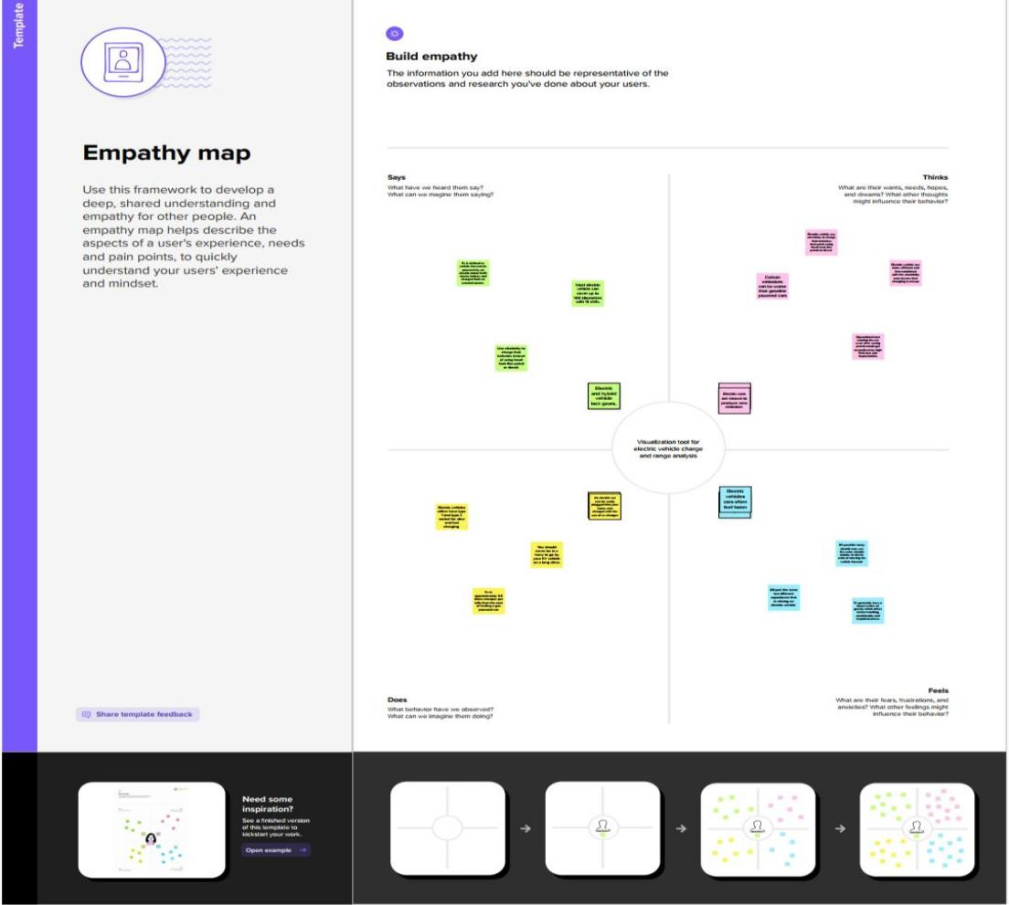 **2.1 Empathy Map**

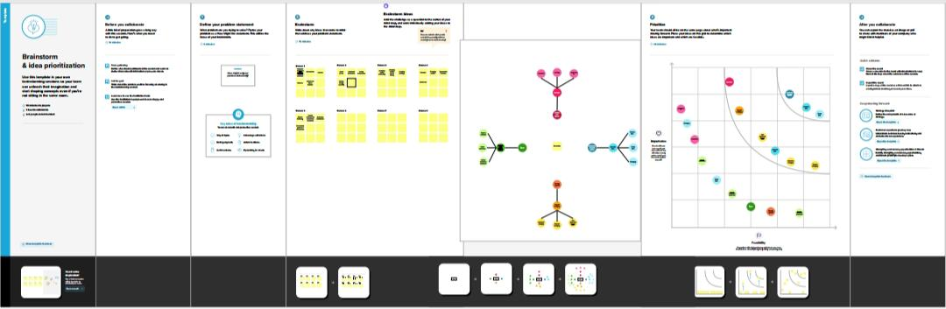**2.2 Ideation and Brainstorming Map**

**3. Results**

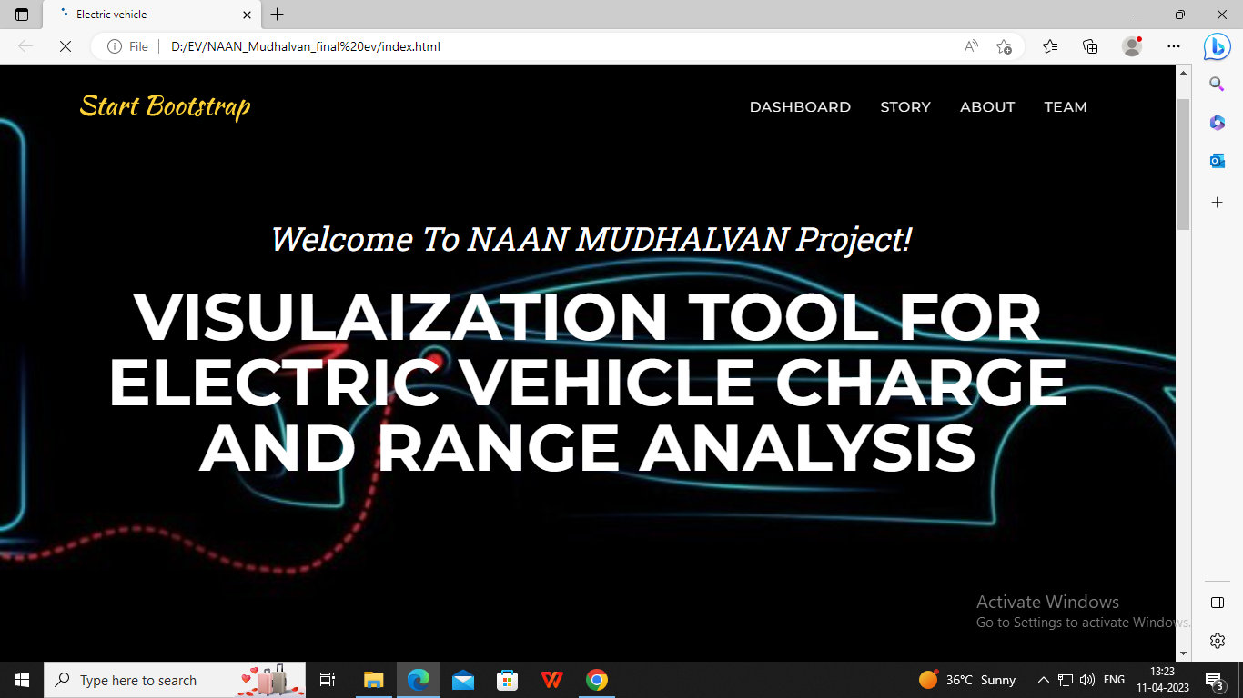

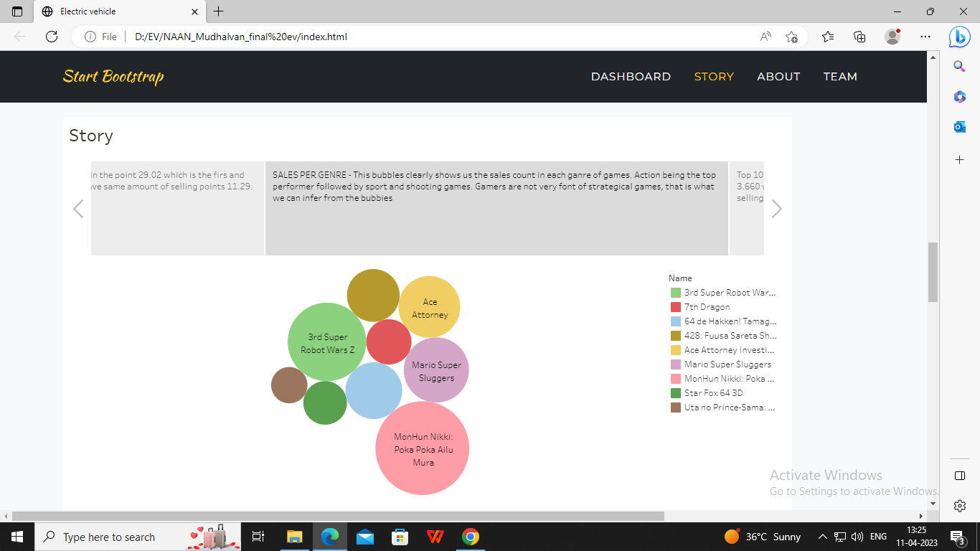

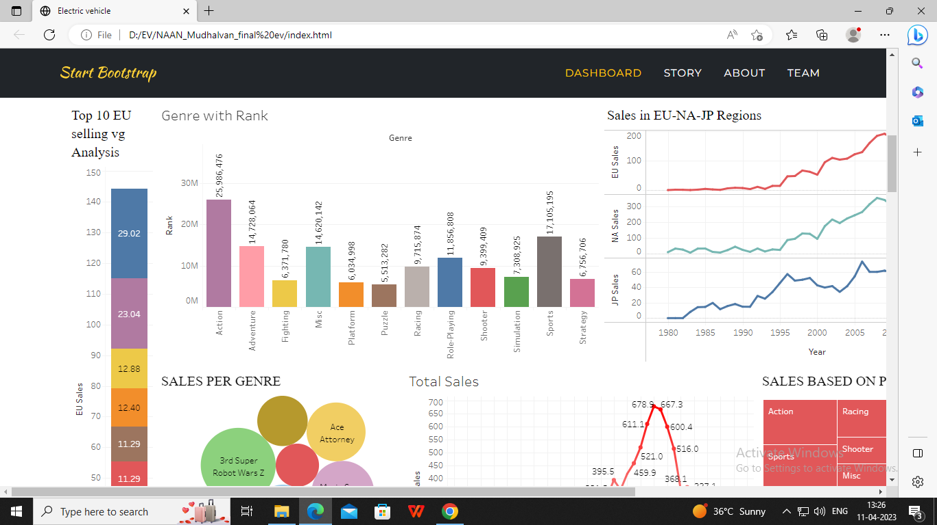

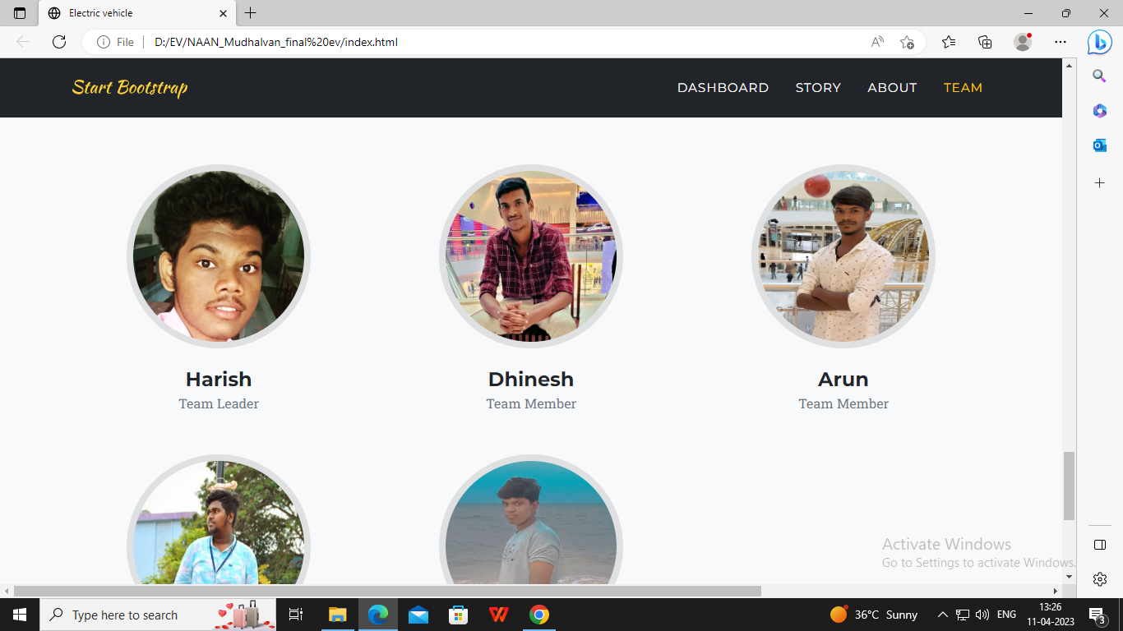

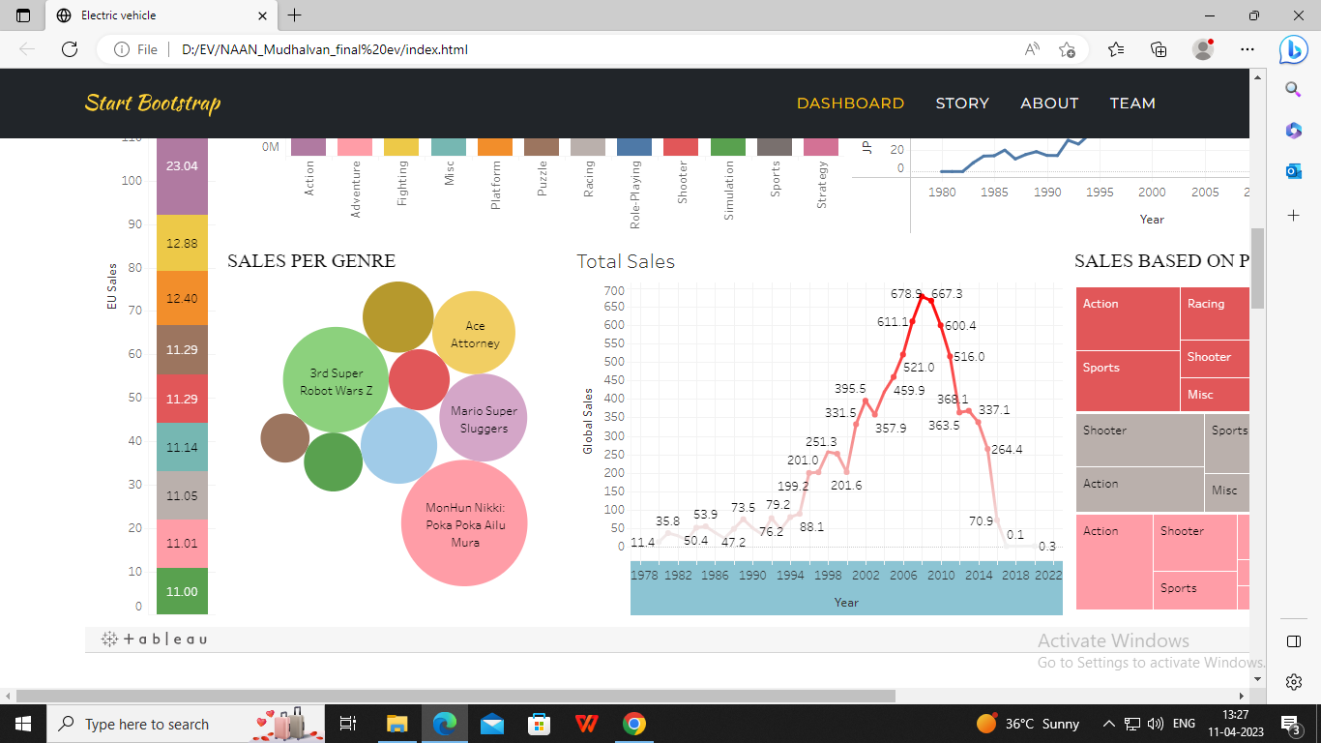

**4.1. Advantage**

* **Lower running costs. Since you are not paying for petrol or diesel to keep your EV running, you save a lot of money on fuel.**
* **Low maintenance costs.**
* **Tax and financial benefits.**
* **Better performance.**
* **Zero tailpipe emissions.**
* **Easy to drive and quiet.**
* **Convenience of charging at home.**
* **No fuel, no emissions.**

**4.2.Disadvantages**

* **Limited Battery Range. The average petrol car can easily do four or five hundred miles on a tank of petrol.**
* **Battery Lifespan Concerns.**
* **Charging Infrastructure Worries.**
* **Long Charging Times.**
* **Low Top Speeds.**
* **More Expensive to Buy.**
* **Environmental Impact.**

**5. Application**

* **Electric vehicles use electricity to charge their batteries instead of using fossil fuels like petrol or diesel.**
* **Electric vehicles are more efficient, and that combined with the electricity cost means that charging an electric vehicle is cheaper than filling petrol or diesel for your travel requirements.**
* **A Battery Management System (BMS), which manages the electronics of a rechargeable battery, whether a cell or a battery pack, thus becomes a crucial factor in ensuring electric vehicle safety.**
* **Main applications are in wireless communication, power tools and mobile computing. These batteries are especially suited for electrically or mechanically arduous applications such as generator starting, hybrid electric vehicles or starting aircrafts.**

**6. Conclusion**

**Conclusion. Currently, electric batteries are not the most popular choice for a battery nor are they anywhere near being the most common used in cars on the road. However, as they continue to get more efficient, cheaper, and easier to dispose of, they can become the most common car battery in our world.**

**7. Future Scope**

* **The EV charging station market is expected to grow 5 to 7 times in the next 5 years. It was valued at 5 billion dollars in 2020 and optimistic predictions see it reach around 35 billion by 2026, which would make EVs represent 15% of all car sales worldwide within 5 years.**
* **Next Gen EV Batteries Will Deliver 500-Mile Range | GreenCars. Everything you need to know, all in one place. The ultimate resource to compare, search, and find electric cars and trucks.**
* **According to a joint report by Indian Venture and Alternate Capital Association (IVCA), Induslaw and EY, the number of charging stations is expected to increase to 100,000 units by 2027 to accommodate the increasing demand by nearly 1.4 million EVs expected to be on the roads by then.**
* **The EV industry in India can create some 10 million or 1 crore direct jobs and 50 million or 5 crore indirect jobs by 2030, according to estimates by the Ministry of Skill Development and Entrepreneurship.**

**8. Appendix**

<!DOCTYPE html>

<html lang="en">

<head>

<meta charset="utf-8" />

<meta name="viewport" content="width=device-width, initial-scale=1, shrink-to-fit=no" />

<meta name="description" content="" />

<meta name="author" content="" />

<title>Electric vehicle</title>

<!-- Favicon-->

<link rel="icon" type="image/x-icon" href="assets/favicon.ico" />

<!-- Font Awesome icons (free version)-->

<script src="https://use.fontawesome.com/releases/v6.3.0/js/all.js" crossorigin="anonymous"></script>

<!-- Google fonts-->

<link href="https://fonts.googleapis.com/css?family=Montserrat:400,700" rel="stylesheet" type="text/css" />

<link href="https://fonts.googleapis.com/css?family=Roboto+Slab:400,100,300,700" rel="stylesheet" type="text/css" />

<!-- Core theme CSS (includes Bootstrap)-->

<link href="css/styles.css" rel="stylesheet" />

</head>

<body id="page-top">

<!-- Navigation-->

<nav class="navbar navbar-expand-lg navbar-dark fixed-top" id="mainNav">

<div class="container">

<a class="navbar-brand" href="#page-top"><img src="assets/img/navbar-logo.svg" alt="..." /></a>

<button class="navbar-toggler" type="button" data-bs-toggle="collapse" data-bs-target="#navbarResponsive" aria-controls="navbarResponsive" aria-expanded="false" aria-label="Toggle navigation">

Menu

<i class="fas fa-bars ms-1"></i>

</button>

<div class="collapse navbar-collapse" id="navbarResponsive">

<ul class="navbar-nav text-uppercase ms-auto py-4 py-lg-0">

<li class="nav-item"><a class="nav-link" href="#services">Dashboard</a></li>

<li class="nav-item"><a class="nav-link" href="#portfolio">Story</a></li>

<li class="nav-item"><a class="nav-link" href="#about">About</a></li>

<li class="nav-item"><a class="nav-link" href="#team">Team</a></li>

</ul>

</div>

</div>

</nav>

<!-- Masthead-->

<header class="masthead">

<div class="container">

<div class="masthead-subheading">Welcome To NAAN MUDHALVAN Project!</div>

<div class="masthead-heading text-uppercase">Visulaization tool for electric vehicle charge and range analysis

</div>

</div>

</header>

<!-- Services-->

<section class="page-section" id="services">

<div class="container">

<div class="text-center">

<h2 class="section-heading text-uppercase">

<div class='tableauPlaceholder' id='viz1680680374235' style='position: relative'><noscript><a href='#'><img alt='Dashboard 3 ' src='https:&#47;&#47;public.tableau.com&#47;static&#47;images&#47;Vi&#47;VideoGamingSellingDashboard&#47;Dashboard3&#47;1_rss.png' style='border: none' /></a></noscript><object class='tableauViz'  style='display:none;'><param name='host_url' value='https%3A%2F%2Fpublic.tableau.com%2F' /> <param name='embed_code_version' value='3' /> <param name='site_root' value='' /><param name='name' value='VideoGamingSellingDashboard&#47;Dashboard3' /><param name='tabs' value='no' /><param name='toolbar' value='yes' /><param name='static_image' value='https:&#47;&#47;public.tableau.com&#47;static&#47;images&#47;Vi&#47;VideoGamingSellingDashboard&#47;Dashboard3&#47;1.png' /> <param name='animate_transition' value='yes' /><param name='display_static_image' value='yes' /><param name='display_spinner' value='yes' /><param name='display_overlay' value='yes' /><param name='display_count' value='yes' /><param name='language' value='en-GB' /></object></div>                <script type='text/javascript'>                    var divElement = document.getElementById('viz1680680374235');                    var vizElement = divElement.getElementsByTagName('object')[0];                    if ( divElement.offsetWidth > 800 ) { vizElement.style.width='1700px';vizElement.style.height='827px';} else if ( divElement.offsetWidth > 500 ) { vizElement.style.width='1700px';vizElement.style.height='827px';} else { vizElement.style.width='100%';vizElement.style.height='2377px';}                     var scriptElement = document.createElement('script');                    scriptElement.src = 'https://public.tableau.com/javascripts/api/viz_v1.js';                    vizElement.parentNode.insertBefore(scriptElement, vizElement);                </script>

</h2>

</div>

</div>

</section>

<!-- Portfolio Grid-->

<section class="page-section bg-light" id="portfolio">

<div class="container">

<div class="text-center">

<h2 class="section-heading text-uppercase">Story</h2>

<div class='tableauPlaceholder' id='viz1680681401362' style='position: relative'><noscript><a href='#'><img alt='Story ' src='https:&#47;&#47;public.tableau.com&#47;static&#47;images&#47;Vi&#47;VideoGamingSellingStory&#47;Story&#47;1_rss.png' style='border: none' /></a></noscript><object class='tableauViz'  style='display:none;'><param name='host_url' value='https%3A%2F%2Fpublic.tableau.com%2F' /> <param name='embed_code_version' value='3' /> <param name='site_root' value='' /><param name='name' value='VideoGamingSellingStory&#47;Story' /><param name='tabs' value='no' /><param name='toolbar' value='yes' /><param name='static_image' value='https:&#47;&#47;public.tableau.com&#47;static&#47;images&#47;Vi&#47;VideoGamingSellingStory&#47;Story&#47;1.png' /> <param name='animate_transition' value='yes' /><param name='display_static_image' value='yes' /><param name='display_spinner' value='yes' /><param name='display_overlay' value='yes' /><param name='display_count' value='yes' /><param name='language' value='en-GB' /></object></div>                <script type='text/javascript'>                    var divElement = document.getElementById('viz1680681401362');                    var vizElement = divElement.getElementsByTagName('object')[0];                    vizElement.style.width='1016px';vizElement.style.height='991px';                    var scriptElement = document.createElement('script');                    scriptElement.src = 'https://public.tableau.com/javascripts/api/viz_v1.js';                    vizElement.parentNode.insertBefore(scriptElement, vizElement);                </script>

</div>

</div>

</section>

<!-- About-->

<section class="page-section" id="about">

<div class="container">

<div class="text-center">

<h2 class="section-heading text-uppercase">About</h2>

<h3 class="section-subheading text-muted"> Rajapalayam Rajus' College, Department of Physics Electric vehicles charging system and range analysis in EV vehicles</h3>

</div>

</div>

</section>

<!-- Team-->

<section class="page-section bg-light" id="team">

<div class="container">

<div class="text-center">

<h2 class="section-heading text-uppercase">crackers of 2023</h2>

<h3 class="section-subheading text-muted">ev analysers.</h3>

</div>

<div class="row">

<div class="col-lg-4">

<div class="team-member">

<img class="mx-auto rounded-circle" src="assets/img/team/1.jpg" alt="..." />

<h4>Harish</h4>

<p class="text-muted">Team Leader</p>

</div>

</div>

<div class="col-lg-4">

<div class="team-member">

<img class="mx-auto rounded-circle" src="assets/img/team/2.jpg" alt="..." />

<h4>Dhinesh</h4>

<p class="text-muted">Team Member</p>

</div>

</div>

<div class="col-lg-4">

<div class="team-member">

<img class="mx-auto rounded-circle" src="assets/img/team/3.jpg" alt="..." />

<h4>Arun</h4>

<p class="text-muted">Team Member</p>

</div>

</div>

<div class="col-lg-4">

<div class="team-member">

<img class="mx-auto rounded-circle" src="assets/img/team/4.jpeg" alt="..." />

<h4>Kaliraj</h4>

<p class="text-muted">Team Member</p>

</div>

</div>

<div class="col-lg-4">

<div class="team-member">

<img class="mx-auto rounded-circle" src="assets/img/team/5.jpEg" alt="..." />

<h4>Bala sundar</h4>

<p class="text-muted">Team Member</p>

</div>

</div>

</div>

</div>

</section>

<!-- Clients-->

<div class="py-5">

<div class="container">

<div class="row align-items-center">

<div class="col-md-3 col-sm-6 my-3">

<a href="#!"><img class="img-fluid img-brand d-block mx-auto" src="assets/img/logos/microsoft.svg" alt="..." aria-label="Microsoft Logo" /></a>

</div>

<div class="col-md-3 col-sm-6 my-3">

<a href="#!"><img class="img-fluid img-brand d-block mx-auto" src="assets/img/logos/google.svg" alt="..." aria-label="Google Logo" /></a>

</div>

<div class="col-md-3 col-sm-6 my-3">

<a href="#!"><img class="img-fluid img-brand d-block mx-auto" src="assets/img/logos/facebook.svg" alt="..." aria-label="Facebook Logo" /></a>

</div>

<div class="col-md-3 col-sm-6 my-3">

<a href="#!"><img class="img-fluid img-brand d-block mx-auto" src="assets/img/logos/ibm.svg" alt="..." aria-label="IBM Logo" /></a>

</div>

</div>

</div>

</div>

<!-- Bootstrap core JS-->

<script src="https://cdn.jsdelivr.net/npm/bootstrap@5.2.3/dist/js/bootstrap.bundle.min.js"></script>

<!-- Core theme JS-->

<script src="js/scripts.js"></script>

<!-- * * * * * * * * * * * * * * * * * * * * * * * * * * * * * * * * * * * * * * * *-->

<!-- * *                               SB Forms JS                               * *-->

<!-- * * Activate your form at https://startbootstrap.com/solution/contact-forms * *-->

<!-- * * * * * * * * * * * * * * * * * * * * * * * * * * * * * * * * * * * * * * * *-->

<script src="https://cdn.startbootstrap.com/sb-forms-latest.js"></script>